Coxsackievirus Infection Facts:
- It is a viral infection caused by Coxsackievirus A16 (most common), A6, or Enterovirus 71 (more severe), a group of viruses that belong to the nonpolio enteroviruses.
- It is known as “hand-foot-and-mouth disease”.
- Symptoms include mouth sores, and a rash on the feet, including around the nailbeds, and hands, including around the nailbeds. The rash may appear:
  - Red
  - White
  - Gray
  - Appear as tiny bumps
  - Blister-like
- It can resemble other rashes, including:
  - Kawasaki disease
  - Kaposi’s sarcoma
  - Herpes simplex virus
  - Herpes zoster (shingles)
  - Viral pharyngitis
  - Erythema multiforme
  - Herpangia
  - Rocky Mountain Spotted Tick Fever
  - Varicella zoster virus (chickenpox)
  - Steven-Johnson syndrome
  - Monkeypox
- Some people also experience fever, sore throat, malaise, painful blister-like lesions on the tongue, gums, and cheeks, blisters on the palms, soles, and buttocks, loss of appetite, and feel sick. Some people lose a fingernail or toenail after having this virus.
- Treatment for the virus is nonspecific.
- The incubation period is 3-6 days, from the time of infection to the time symptoms appear.
- It spreads via person-to-person contact (direct), contact with contaminated surfaces or objects like doorknobs or countertops (fomites) (indirect), AND through contact with infected respiratory droplets (cough, sneeze, nasal secretions, throat discharge), saliva, drool, fluid from blisters, AND stool.
- Transmission isolation precautions should be put into place: Droplet-Contact and make sure to wash hands with soap and water in between gloves.
- It is highly contagious, especially during the first week of the illness!!!
- It is most common in children in school and daycare, but some people, particularly adults, can pick it up if they are immunocompromised. Adults can also be asymptomatic yet shed and spread the virus.
- The virus can stay in the body for WEEKS after the symptoms disappear.
- Most adults already have immunity against the virus.
- Complications can include dehydration since it is painful to swallow, rare viral meningitis, or rare encephalitis, which more severe and potentially life-threatening complications. It can also cause rare interstitial pneumonia, myocarditis, pancreatitis, or pulmonary edema.
  - Symptoms of brain infection: fever, stiff neck, headache, back pain, swelling of the brain, paralysis, Guillain-Barre syndrome, cerebellar ataxia. If these symptoms are noted in an inpatient, brain imaging studies should be ordered.
- Hand washing often with soap and water for at least 20 seconds is best between patient contact and between glove changes.
- Disinfect all contact surfaces and areas with a bleach and water wipe or solution.
- Avoid close contact, so exposure should be limited. Precautions should remain in place until the fever is gone and mouth sores have healed (at least 24 hours after these things have resolved).
- Diagnosis: Diagnosis is typically based on signs, symptoms, and a viral panel can be ordered.
References:
- https://www.mayoclinic.org/diseases-conditions/hand-foot-and-mouth-disease/symptoms-causes/syc-20353035
- https://www.cdc.gov/hand-foot-mouth/about/transmission.html
- https://www.ncbi.nlm.nih.gov/books/NBK431082/
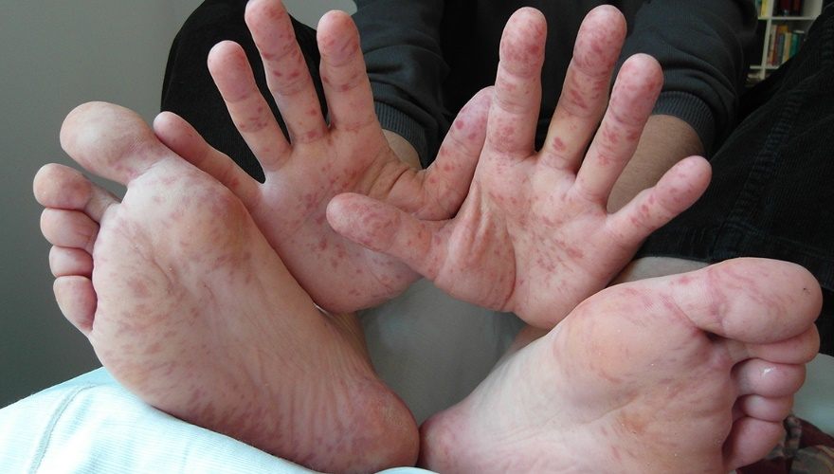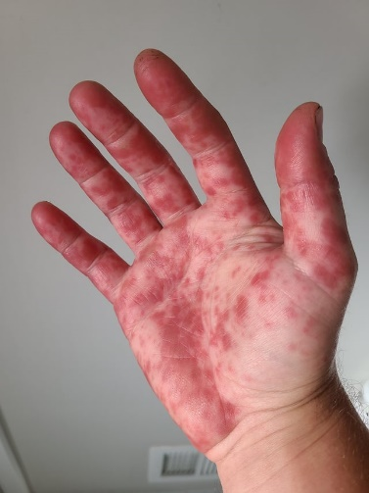
https://www.google.com/url?sa=i&url=https%3A%2F%2Fvitalrecord.tamhsc.edu%2Fhand-foot-and-mouth-disease-signs-symptoms-and-treatment%2F&psig=AOvVaw3Yd-hedfiWCUp5X1qNCpxM&ust=1710087967971000&source=images&cd=vfe&opi=89978449&ved=0CBEQjRxqFwoTCLjc36bM54QDFQAAAAAdAAAAABAD
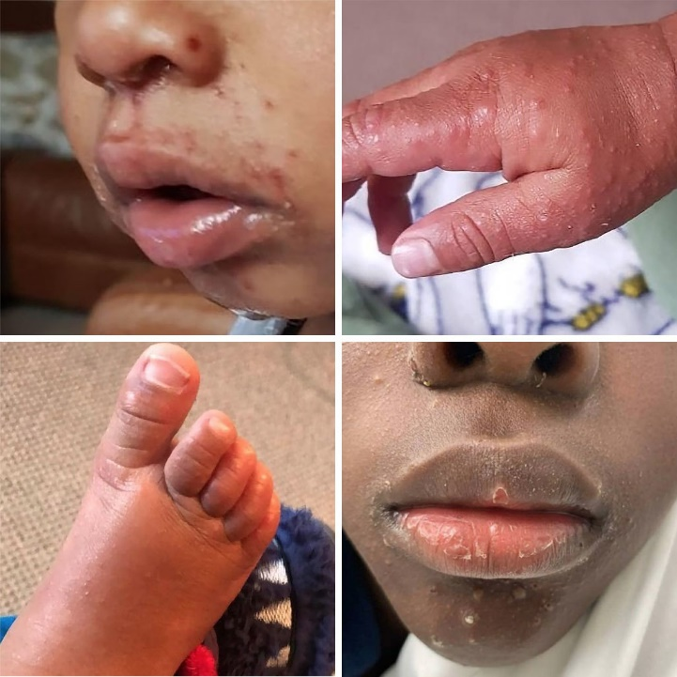
https://assets.babycenter.com/ims/2022/10/brownskinmatters-hfmd-collage-2022.jpg

